**Assignment cntd : Linux Commands**

26 Iostat :iostat is the basic workhorse utility for monitoring I/O device activity on the system

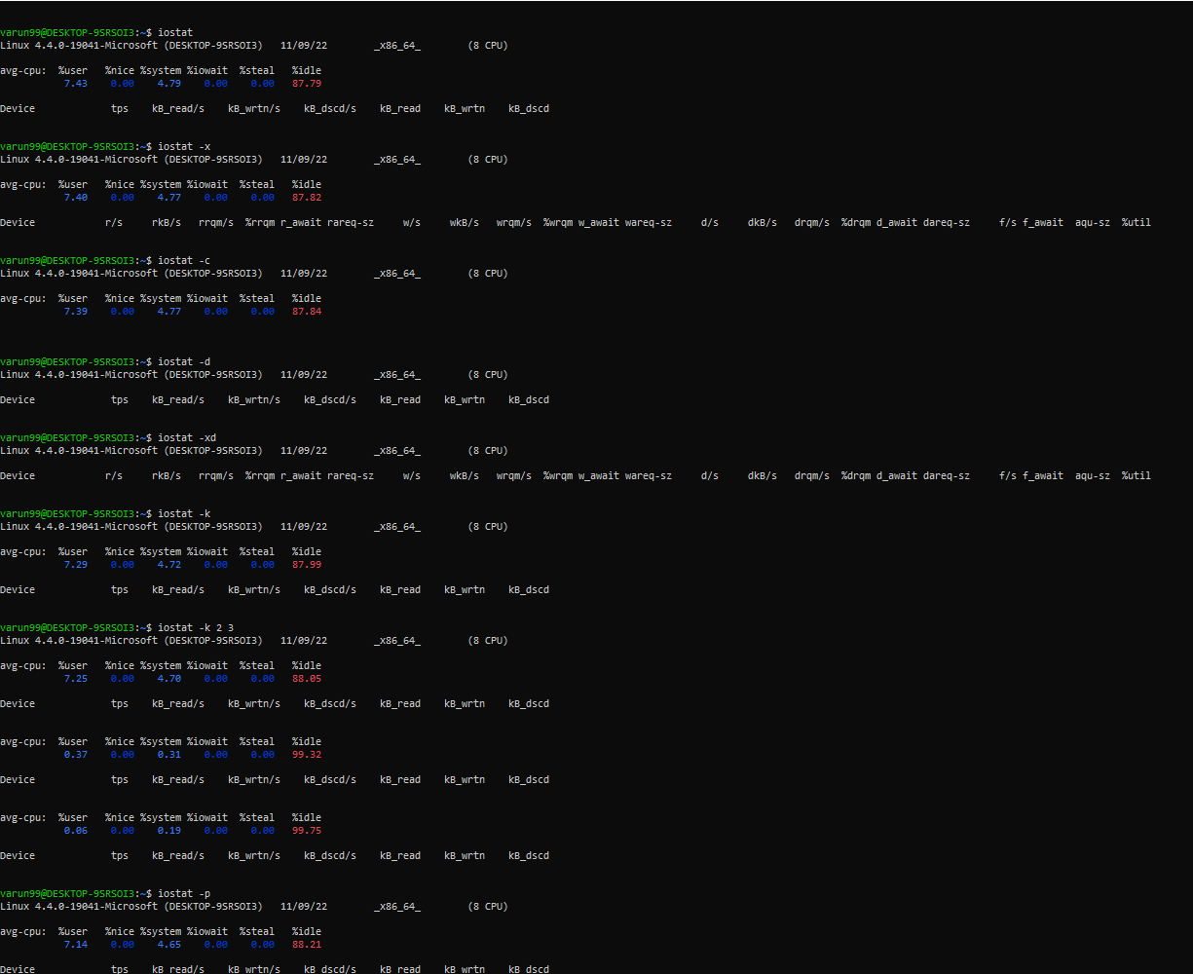

27 Clear : Clear the terminal display



28 diff : The command will compare data between two text files and display the difference



29 : Echo : Can be used to identify current user.



30 : Exit : It does is exit the shell in which it is active.

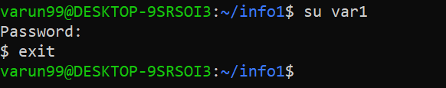

31 : finger : to look up and obtain brief information on users.

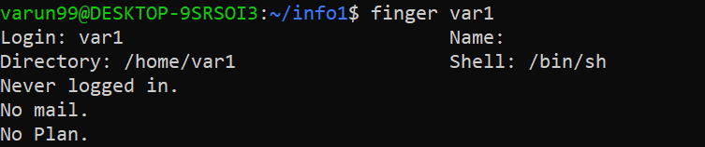

32 Free : The free command-line utility provides users with a summary of the total available free space on the computer

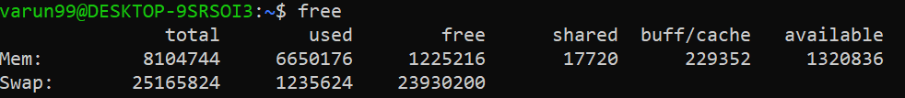

33 dmidecode : midecode command is used when the user want to retrieve system’s hardware related information



34 : History : To know the commands that we have used previously.

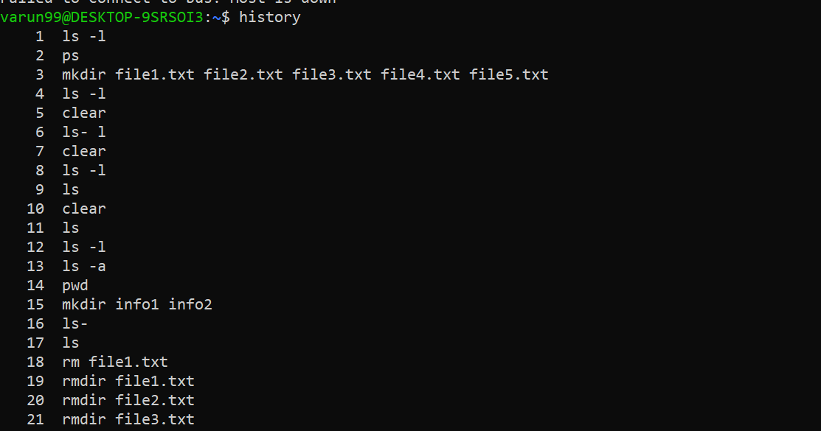

35 : less : With the less command, one does not have to use an editor to view files.

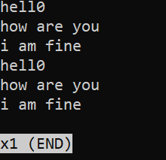

36 : ping : To know the internet status

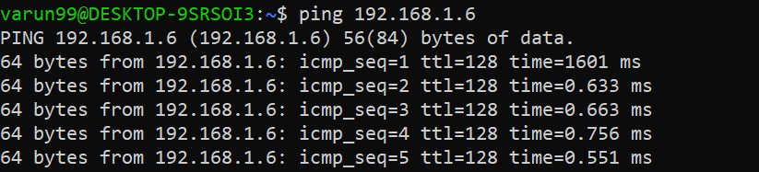

37 : Netstat : The netstat is a command-line tool that presents an overview of the network connections.



38 : Uptime : print current time when machine starts



39 : ifconfig – print ip address.

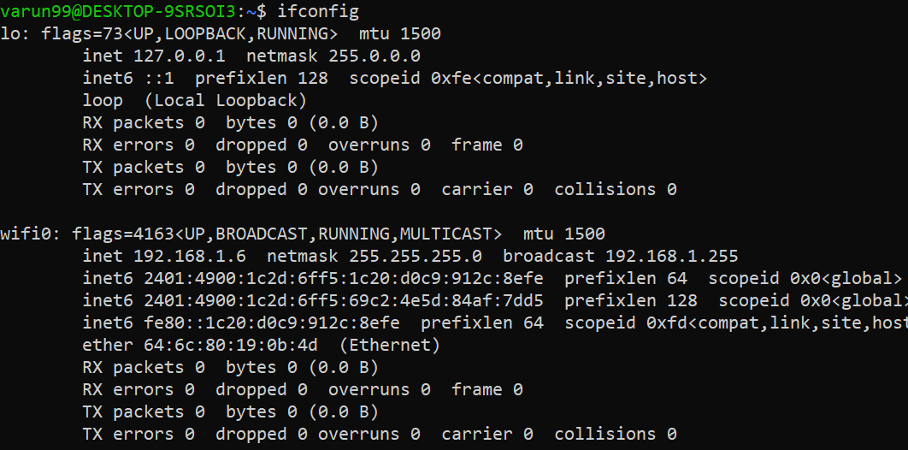

40 : Bc : is another cool and useful command for Linux users as it allows you to enable command line calculator in Linux Terminal

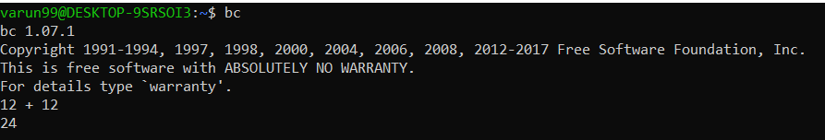

41 : Factor : give you all the possible factors of the decimal number

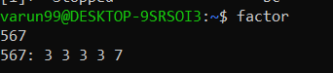

42 : Banner : will display whatever text you type will be displayed in big banner format

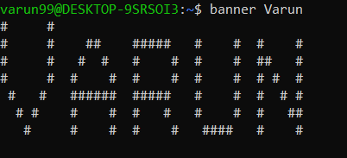

43 : *w:*  is the short and simple command which will help you view the list of currently logged in users.



44 :  lscpu : This command will display all the CPU architecture information such as threads, sockets, cores and CPU count.

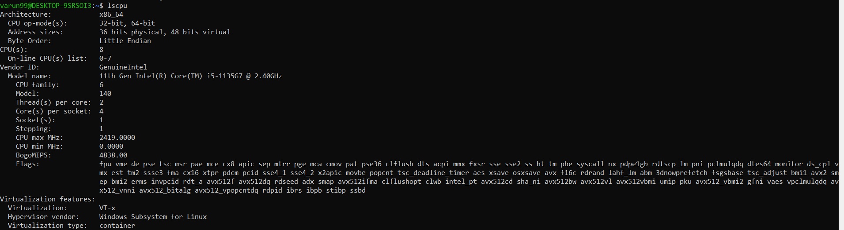

45 : cksum is a command to generate the checksum value for the file



46 : cmp : Compares byte to byte info of two files.



47 :  last command will display the list of last logged in users into the system

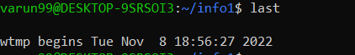

48 : Man : Used to display the manual

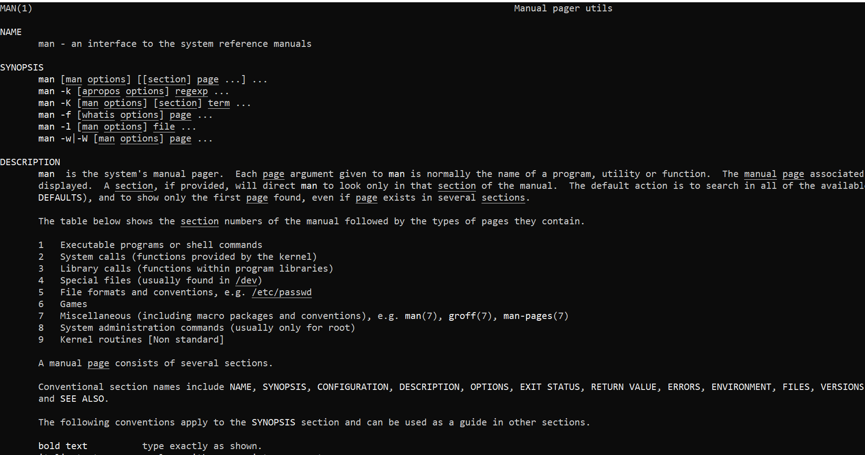

49 : Useradd : Adds the new user to the system

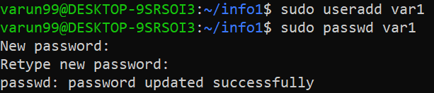

50 gruopadd : Creates/adds a new group to the system

